CSE 4571 – PRACTICAL ROBOTICS PROJECTS WITH ARDUINO
EXPERIMENT 1
Ultrasonic Sensor-Based Distance Measurement and Obstacle Detection Using Arduino
Duration | Level | Mode | CO Mapping
2 Hours | B.Tech CSE Final Year | Hardware / Wokwi | CO1, CO2, CO6
1. Aim of the Experiment
To interface an HC-SR04 ultrasonic sensor with an Arduino UNO, measure object distance, and implement threshold-based obstacle detection using LEDs and a buzzer.
2. Learning Objectives
- Understand ultrasonic time-of-flight distance measurement.
- Interface a digital distance sensor with Arduino UNO.
- Acquire echo duration and convert it into distance.
- Implement threshold-based decision making.
- Use LED and buzzer outputs as visual and audible alerts.
- Develop confidence in basic sensor–controller–actuator integration.
3. Components (TinkerCAD/ Wokwi & Hardware Parts)
Component | Quantity | Purpose
Arduino UNO | 1 | Microcontroller
HC-SR04 Ultrasonic Sensor | 1 | Distance measurement
Red LED | 1 | Danger indication
Yellow LED | 1 | Warning indication
Active Buzzer | 1 | Audible alert
220 Ω Resistor | 2 | LED current limiting
Breadboard | 1 | Circuit assembly
Jumper Wires | As required | Interconnections
4. Theory
The HC-SR04 emits an ultrasonic burst at approximately 40 kHz through its TRIG interface. The sound wave reflects from an object and the ECHO pin remains HIGH for a duration proportional to the round-trip travel time. Arduino measures this pulse width and converts it to distance.
Distance (cm) = Echo time (µs) / 58
For this experiment, three simple decision zones are used: 0–10 cm = DANGER, 10–25 cm = WARNING, and above 25 cm = SAFE.

5. Pre-Lab Questions
- What is the operating principle of an HC-SR04 sensor?

- Why are separate TRIG and ECHO pins required?

- What is the approximate speed of sound in air?

- Why is pulseIn() used in this experiment?

- Why should LEDs be connected through current-limiting resistors?

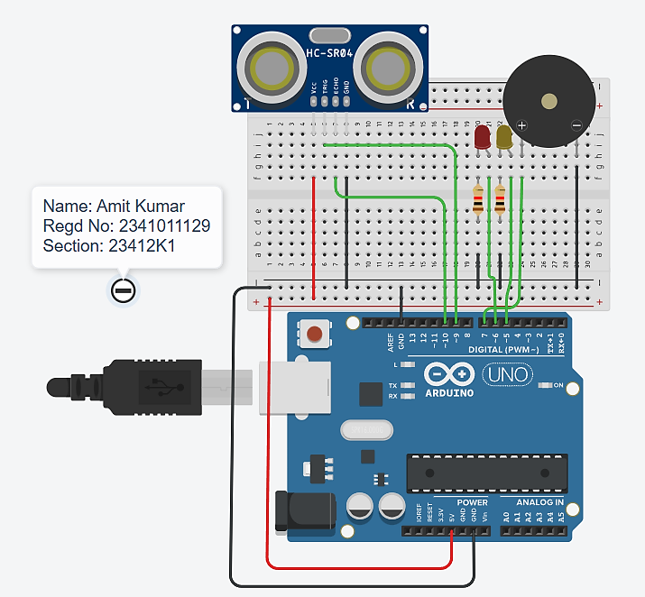
6. Circuit Diagram Implemented Using TinkerCAD/Wokwi

Figure 1. Software Implemented Ultrasonic Sensor-Based Distance Measurement and Obstacle Detection.
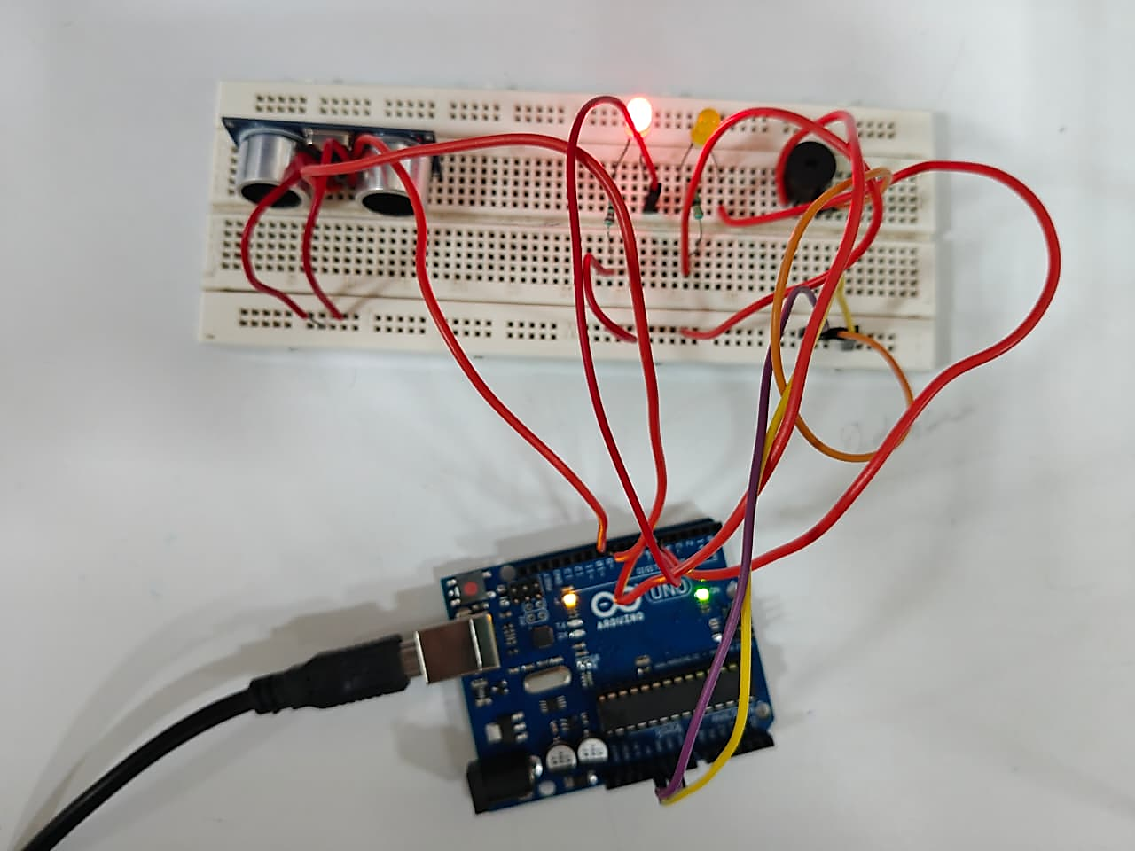
7. Circuit Diagram Implemented Using Hardware’s

Figure 2. Hardware Implemented Ultrasonic Sensor-Based Distance Measurement and Obstacle Detection.
8. Connection Table
Device Pin | Arduino Pin | Connection / Note
HC-SR04 VCC | 5V | 5 V supply
HC-SR04 TRIG | D9 | Digital output
HC-SR04 ECHO | D10 | Digital input
HC-SR04 GND | GND | Common ground
Red LED (+) | D6 | Through 220 Ω resistor
Yellow LED (+) | D5 | Through 220 Ω resistor
Buzzer (+) | D7 | Buzzer (−) to GND
9. Procedure
1. Place the Arduino UNO and components on the breadboard.
2. Complete all power and ground connections first.
3. Connect the HC-SR04 TRIG and ECHO pins to D9 and D10 respectively.
4. Connect the LEDs through 220 Ω resistors and connect the buzzer to D7.
5. Open Arduino IDE or the corresponding Wokwi simulation.
6. Enter and compile the program given below.
7. Upload/run the program and open Serial Monitor at 9600 baud.
8. Vary the target distance and record at least five observations.
9. Verify that the LED and buzzer responses agree with the defined distance zones.

10. Arduino Program
const int TRIG = 9;
const int ECHO = 10;
const int RED_LED = 6;
const int YELLOW_LED = 5;
const int BUZZER = 7;
float getDistance() {
digitalWrite(TRIG, LOW);
delayMicroseconds(2);
digitalWrite(TRIG, HIGH);
delayMicroseconds(10);
digitalWrite(TRIG, LOW);
long duration = pulseIn(ECHO, HIGH, 30000);
if (duration == 0) {
return -1;
}
return duration / 58.0;
}
void setup() {
Serial.begin(9600);
pinMode(TRIG, OUTPUT);
pinMode(ECHO, INPUT);
pinMode(RED_LED, OUTPUT);
pinMode(YELLOW_LED, OUTPUT);
pinMode(BUZZER, OUTPUT);
digitalWrite(RED_LED, LOW);
digitalWrite(YELLOW_LED, LOW);
noTone(BUZZER);
}
void loop() {
float distance = getDistance();
digitalWrite(RED_LED, LOW);
digitalWrite(YELLOW_LED, LOW);
noTone(BUZZER);
if (distance < 0) {
Serial.println("Distance: No echo / out of range");
}
else if (distance <= 10.0) {
digitalWrite(RED_LED, HIGH);
tone(BUZZER, 1000);
Serial.print("Distance: ");
Serial.print(distance, 2);
Serial.println(" cm -> DANGER -> RED LED ON -> BUZZER ON");
}
else if (distance <= 25.0) {
digitalWrite(YELLOW_LED, HIGH);
noTone(BUZZER);
Serial.print("Distance: ");
Serial.print(distance, 2);
Serial.println(" cm -> WARNING -> YELLOW LED ON -> BUZZER OFF");
}
else {
noTone(BUZZER);
Serial.print("Distance: ");
Serial.print(distance, 2);
Serial.println(" cm -> SAFE -> YELLOW LED OFF -> BUZZER OFF");
}
delay(500);
11. Observation Table
Sl. No. | Actual Distance (cm) | Measured Distance (cm) | Error (cm) | Zone | Buzzer State
1 | 50.00 | 50.14 | 0.14 | SAFE | OFF
2 | 40.00 | 40.24 | 0.24 | SAFE | OFF
3 | 30.00 | 30.29 | 0.29 | SAFE | OFF
4 | 20.00 | 20.16 | 0.16 | WARNING | OFF
5 | 9.00 | 9.05 | 0.05 | DANGER | ON
12. Result
The HC-SR04 ultrasonic sensor was successfully interfaced with Arduino UNO. Object distance was measured and classified into safe, warning, and danger zones, with corresponding LED and buzzer indications.
13. Post-Lab / Application Questions
- Calculate the percentage error for any three readings.

- Modify the thresholds to 15 cm and 30 cm and verify the outputs.

- How would you reduce false triggering caused by noisy distance readings?

- How can this circuit be extended into an autonomous obstacle-avoiding robot?

- What changes would be required to control a DC motor based on the measured distance?

14. Student Record
Amit Kumar | 2341011129
Student Name | Registration No. | Date | Faculty Signature

